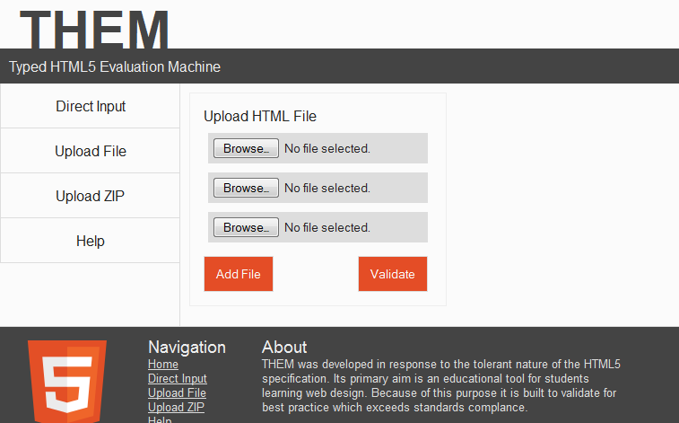
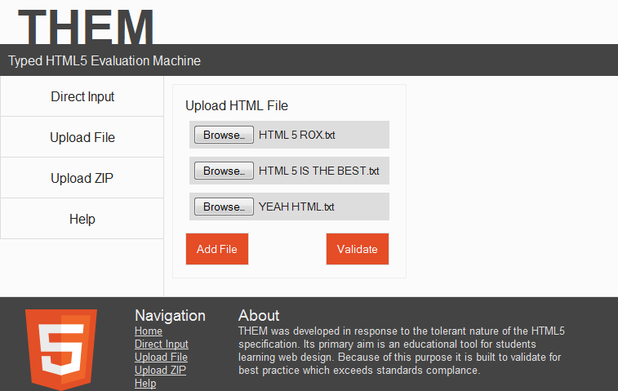
Upload File
1. Navigate to Upload File page.
2. Browse to upload file(s).
3. Validate the file(s).
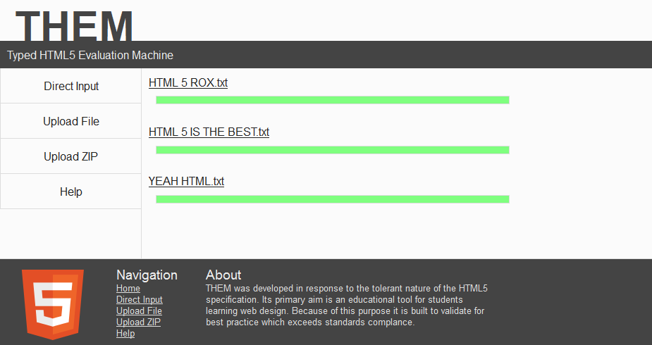
All good!

